**Shubhangi Agarwal**

**Self-Work Report 1**

**Status**

Implemented work

* Basic database model for taking user input (Through Django, sqlite3)
* Handling http_requests and responses (Through Django)
* Addition of user input into training data (Through Django)
* A REST API for connecting with frontend (Through Django)
* API mapping to create a request from React to Django (Through React.js)

In Progress

* Connection of frontend with backend for getting an end-to-end workflow

**Backend Details**

Final Database Schema (As discussed with all)

* Partner : {

id : AutoField, primary key

firstName : CharField

lastName : CharField

email : EmailField

contact : CharField

address : CharField

city : CharField

state : CharField

typestore : CharField

size : CharField

workingemployees : PositiveIntegerField

customers : PositiveIntegerField

service : CharField

password : CharField

confirmPassword : CharField

}

Initial Database Schema (self-thought)

* Partner : {

id

FirstName

LastName

Email

Contact

Age

Password

Location of the store (city,state,pincode)

Number of employees working in the store

Type of store

Size of store

Google maps rating

Annual sales of the store

Additional info.

Website link

Storage size willing to give to the locker

}

Routes

* webapp/api/partners/list/ : { method : ‘post’ , ‘get’ }
* webapp/api/partners/list/details/ : { method : ‘put’ , ‘delete’ }

Requests and responses

**{ ‘request_method’ ? response_if_true : response_if_false }**

* ‘get’ ? data stored in ‘Partner’ database : HTTP_400_BAD_REQUEST
* ‘post’ ? HTTP_201_CREATED : HTTP_400_BAD_REQUEST
* ‘put’ ? HTTP_204_NO_CONTENT : HTTP_400_BAD_REQUEST
* ‘delete’ ? HTTP_204_NO_CONTENT : HTTP_400_BAD_REQUEST

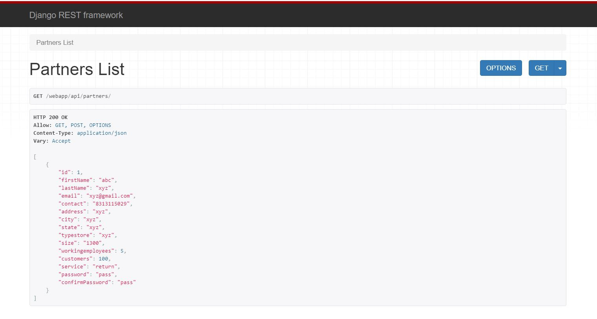

**Fig. 1:** Response for ‘get’ request

**Technical Challenges Faced**

* Understanding MVC and MVT architecture : Solved
* Database creation through Django : Solved
* Sending requests from React app to Django : In Progress